IT OU GPO Implementation
Description:
- Implemented core IT security policies for the IT Users OU to simulate a realistic corporate environment.
- Password Policy: Enforced complex passwords with a 90-day expiration to improve account security.
- Account Lockout Policy: Locked user accounts after 5 failed login attempts with a 15-minute reset, preventing brute-force attacks.
- USB Device Restriction: Blocked access to all removable storage to reduce the risk of malware and unauthorized data transfer.

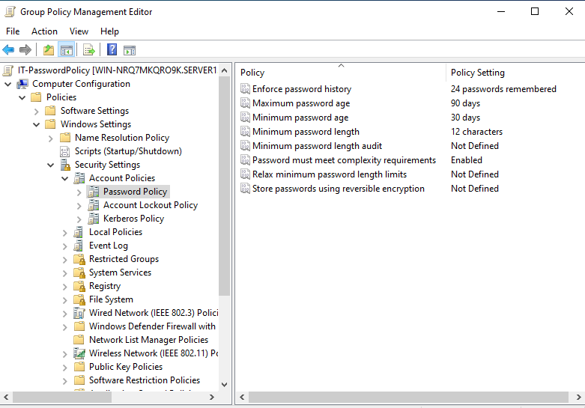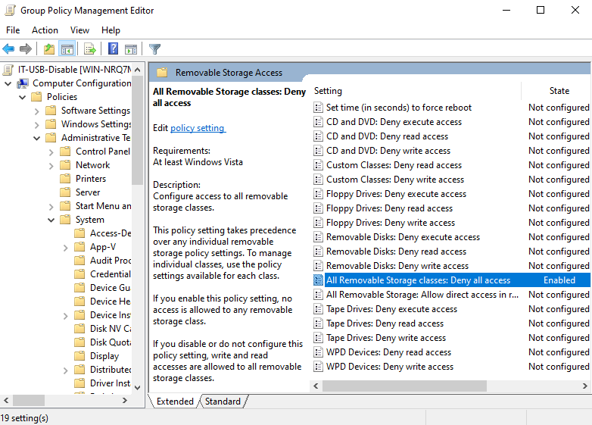
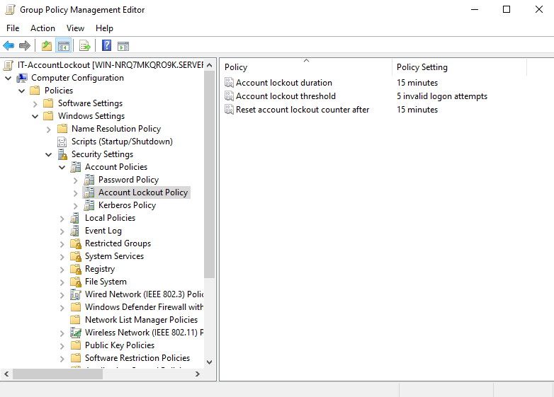
HR OU GPO Implementation
Description:
- Implemented core HR user policies in the HR Users OU to simulate a realistic corporate environment with a balance of usability and security.
- Password Policy: Enforced moderate complexity passwords with a 90-day expiration to protect user accounts while remaining user-friendly.
- Account Lockout Policy: Locked accounts after 5 failed login attempts with a 15-minute reset to prevent unauthorized access via brute-force attacks.
- Control Panel Restriction: Blocked access to the Control Panel and PC settings, reducing risk of accidental or unauthorized system changes.

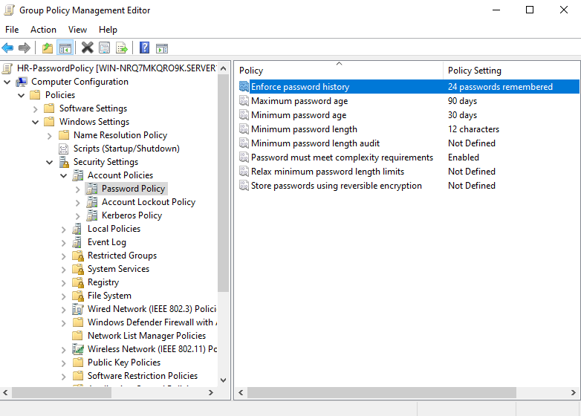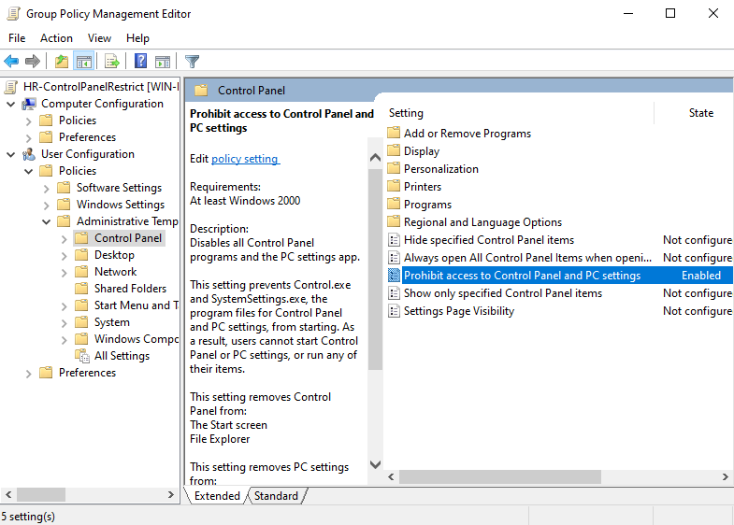
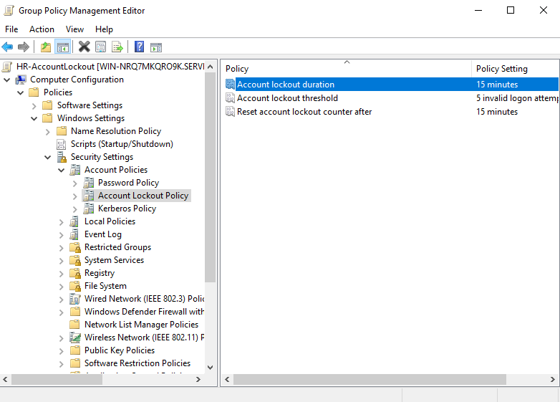
Accounting OU GPO Implementation
Description:
- Implemented key security and operational policies for the Accounting Users OU to simulate a corporate environment managing sensitive financial data.
- Password Policy: Enforced complex passwords with a 60-day expiration to ensure strong account security.
- Account Lockout Policy: Locked accounts after 5 failed login attempts with a 15-minute reset to prevent unauthorized access.
- USB Device Restriction: Blocked all removable storage to reduce risk of malware and data exfiltration.
- Deny Logon Locally: Prevented Accounting users from logging in on non-Accounting machines, improving endpoint security.
- Allow Remote Desktop Services: Enabled remote logon for Accounting users to access authorized systems securely.

